As I.T. professionals we should be aware of the latest trends in the field. This requires downloading and installing dozens of bundles of packages and building a lot of environments. So our gonna do all that on our personal computers??? of course not.

Using a virtual machine. And that is a good choice THAN a hardware cost and it's relatively easy to set up configure and destroy when not needed any more than traditional physical hardware. However it takes time and effort to set up. It takes more time to download and install and deployed the necessary packages.

Post the OS, configuration files to fix any errors and so on and so forth.

In addition, you'll often be working in a team where each developer will be needing a slightly different environment to fit his or her own needs. As you know, more machines and more time wasted.

**1.) What if I told you that you can download a complete development environment that is an OS prepackaged with the necessary tools libraries and services that enables you to start working right off??????**

**2.) One of this very same environment can be shared among different users and of-course version control systems like git. Each one can have a customized copy.**

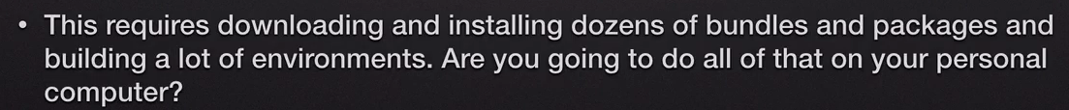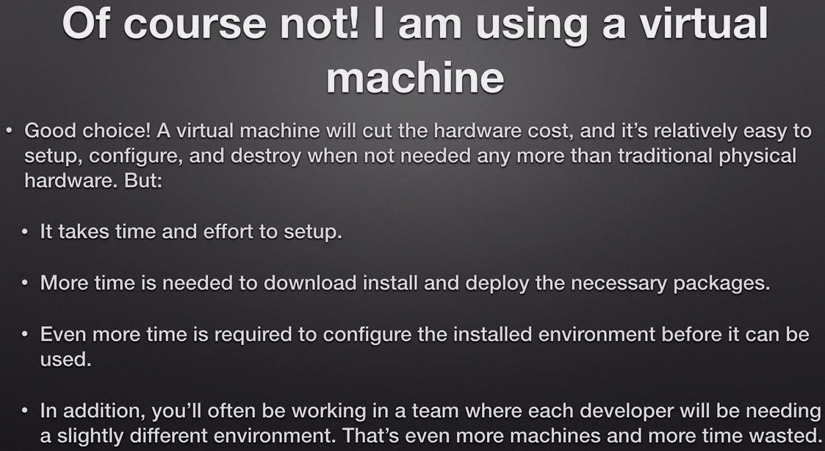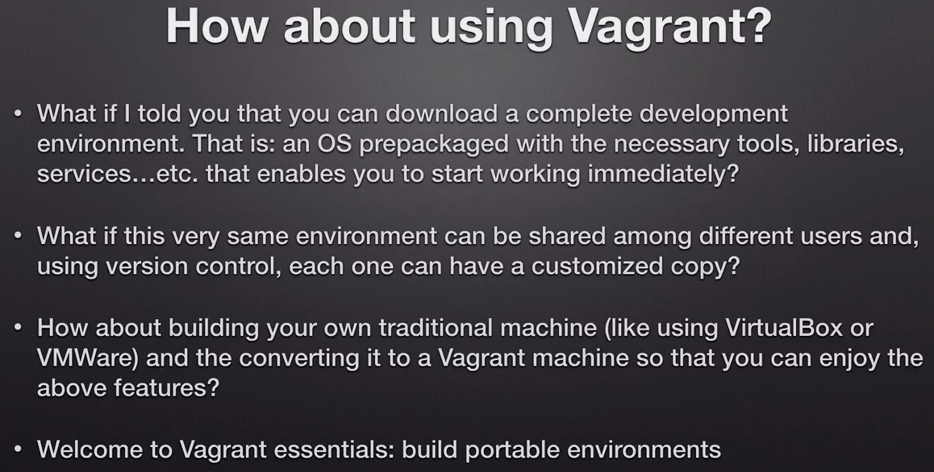

As you can see here using this virtual tool this guy is acting as if he is inside a data center full of computer racks that you can see here behind him. You have a lot of server racks. These are virtual. These are not real.

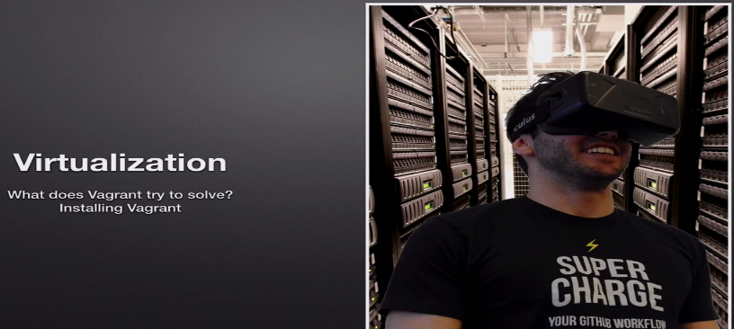Now in order to know what virtualization is you have to have a look at how life was before transition was introduced. I'm talking here about the life of a developer someone who spends most of his work time developing projects and writing code building and running this code on his or her machine spotting bugs returning back to the editor doing changes adding features and then building and testing and so on. This is the typical workflow of a developer.

If you are a developer living in those days where because it was not available to desktop computers you had to use your own machine for your development tasks. This meant installing the infrastructure on your Prabhat computer or so for example if you have perhaps a separate hard disk for your development a second network card a second physical network card. If you got test connecting to a different network so first thing is installing the infrastructure on your private computer and by infrastructure I mean the services that the software depends on to run.

So for example if you are if you want to run a web application written in for example Angular js or PHP. For example this application would need a web server first. So we're going to have to install either Apache or nginx or whatever the web server was to the first thing I stole is the operating system. And most people prefer Linux and Unix variants over Windows when they are developing with applications written in PHP. Of course this is not a requirement but it's just how things go in web development.

difficult choice whether you're going to install Windows as the primary operating system for a machine or you're going to resort to one of these distros like Redhat for example or a buntu this of course spent at this operating system will be both your development operating system which means that this is the operating system or what you're going to develop your applications.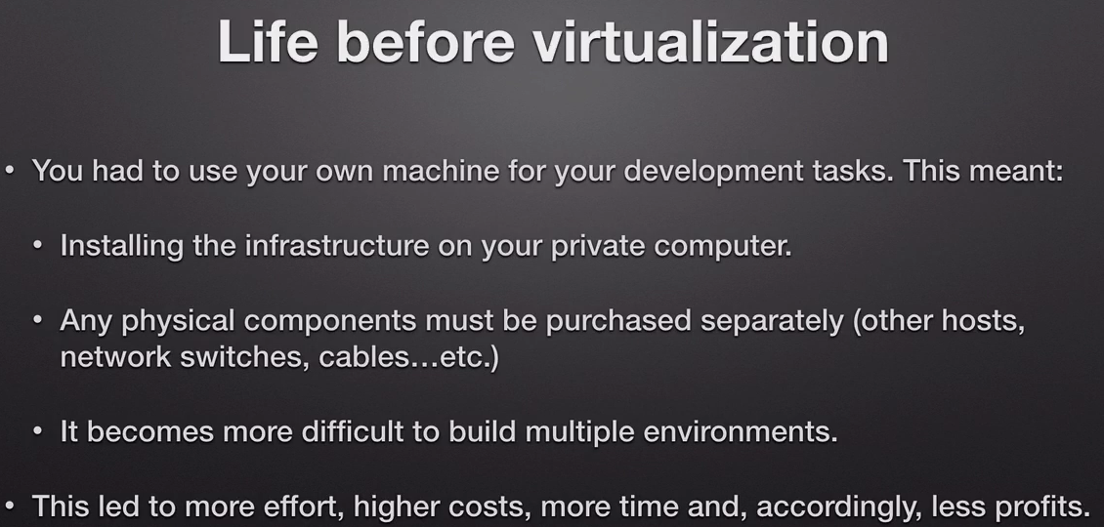

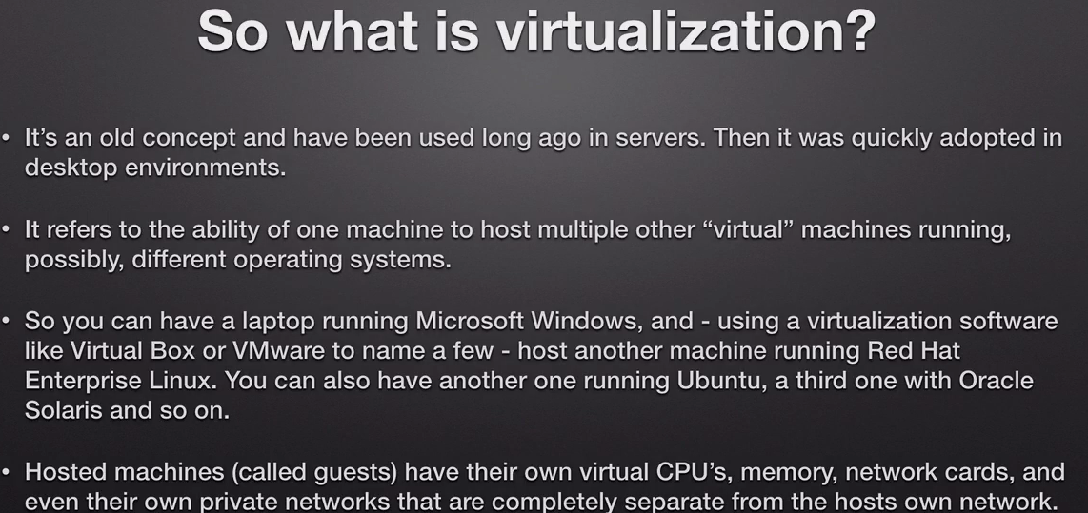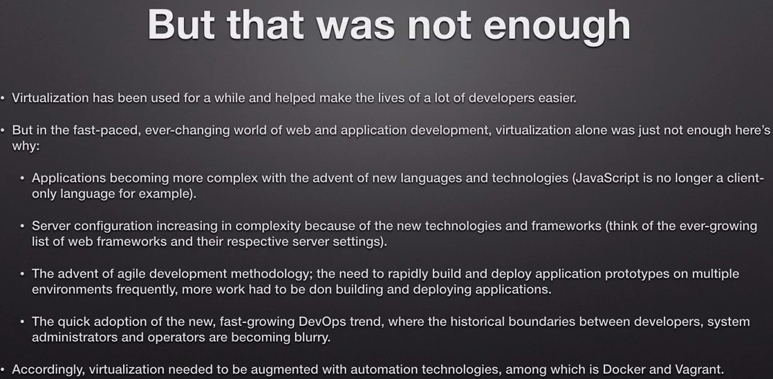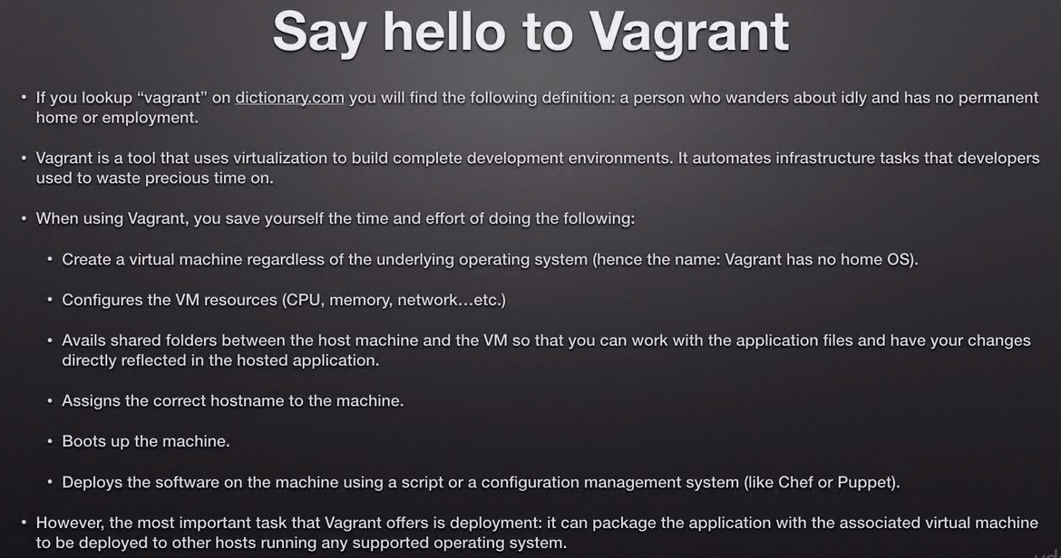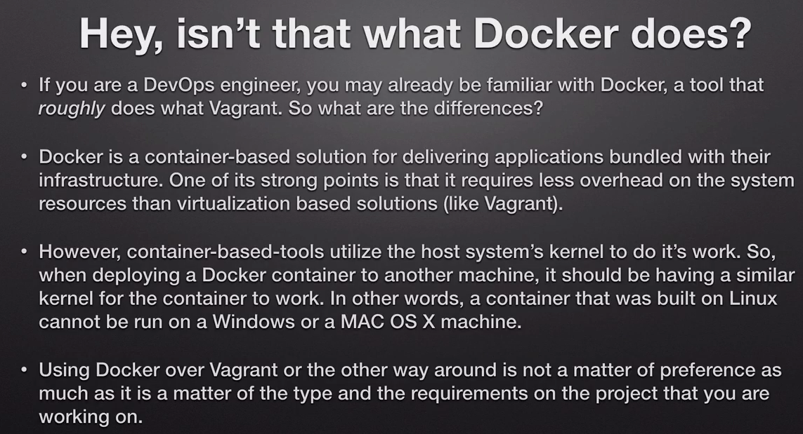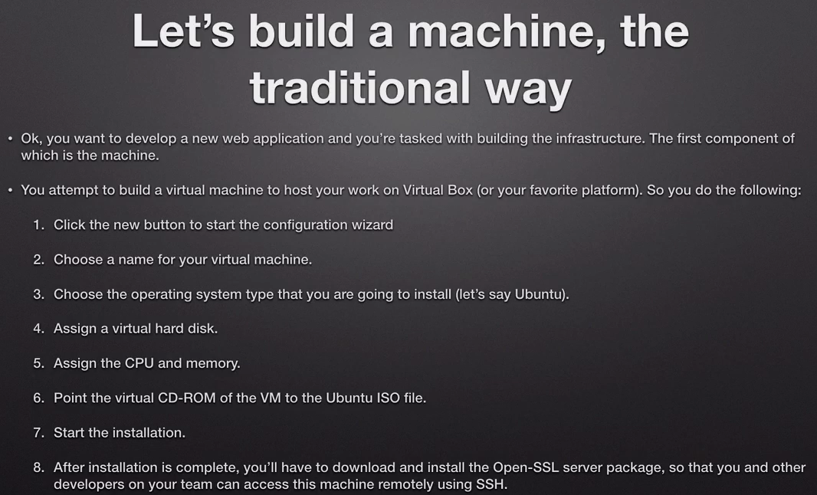

Once downloaded, we can use it as template for other boxes.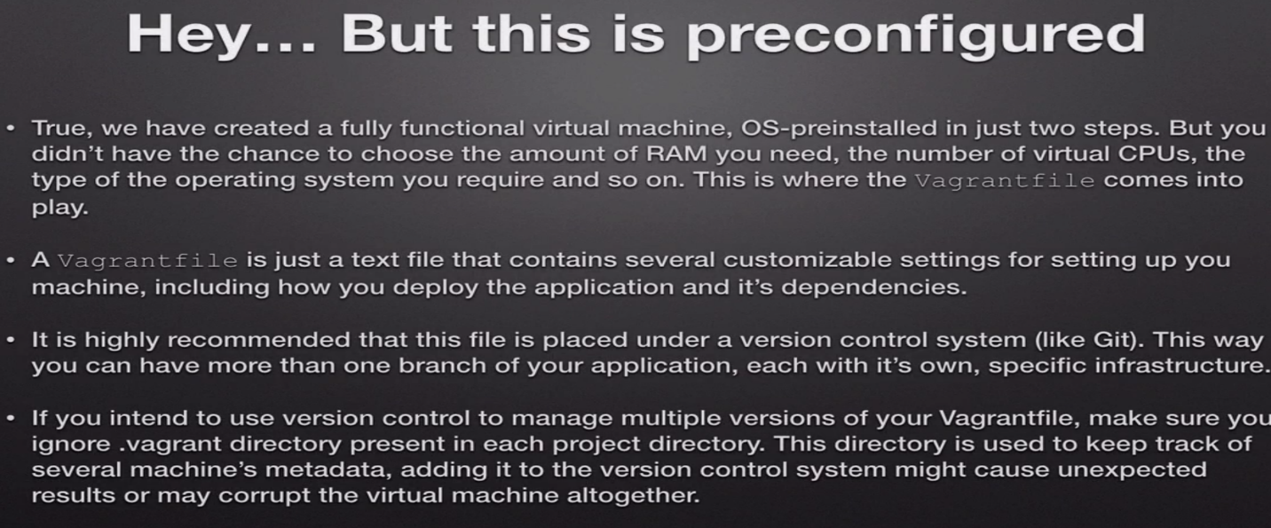

And it is highly recommended that this file be placed under a version control system like git.

The point is to keep several versions of this file so that different developers can work with different versions of versions of this file. And as we are going to go through this section and through discourse you can see that the bigger file contains a lot of options that completely change their behavior and the the characteristics and deployment options of the big machine that you're going to use. So when different people on different developers are going to work with one big run machine.

It's very nice to have several versions of this file so that they can check out from branches on different versions of the file reload the machine as we're going to see in this section to apply changes and work in their own project or or in their own testing scenarios and so on and so forth. And just a recommendation.

Make sure you ignore .vagrant directory(metadata) using .gitignore.

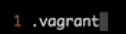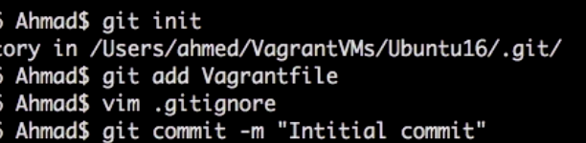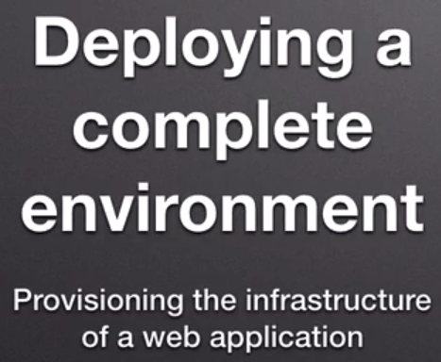

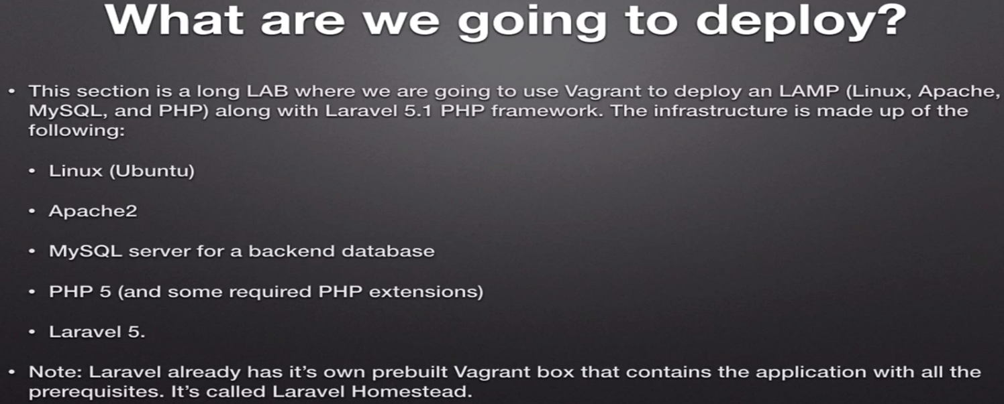

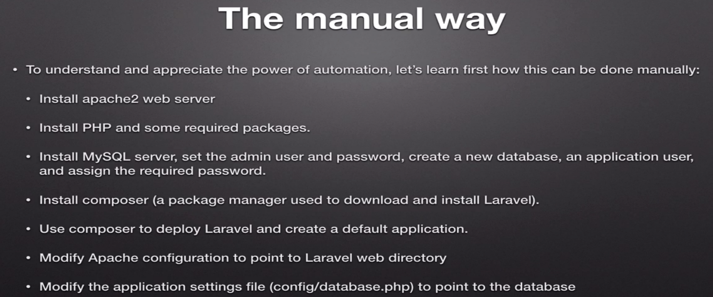

Step-1:1,2

sudo apt-get install apache2 php php-zip unzip php-mbstring libapache2-mod-php phpunit zip

step-3: Manual way Configure mysql user, password

sudo apt-get install -y mysql-server

It will ask for password

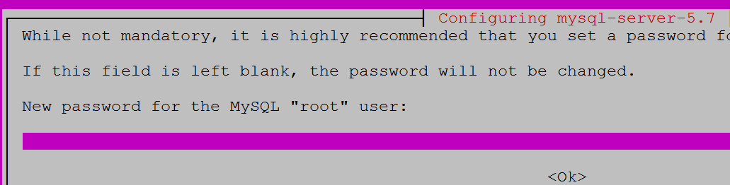

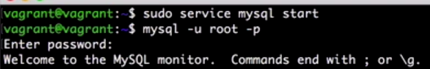

sudo apt-get install -y mysql-server

service mysql status

mysql -u root –p

CREATE DATABASE myproject;----Create dabase

CREATE USER 'user1'@'localhost' IDENTIFIED BY 'mypassword';----Create user to be able to connect to database

GRANT ALL PRIVILEGES ON myproject.* TO 'user1'@'localhost'; ----Granting all priveleges on Project to user.

Also means user will not be having privileges other than, he normally have on APPLICATION DB

FLUSH PRIVILEGES;---Since we are creating password, and giving privileges to user...run this command

-----------------------------------------------------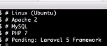Now, let’s install Laravel framework.

This is not part of LAMP stack.Just addon

**Install Composer:**

1.) curl -s http://getcomposer.org/installer | php

Note: This should be installed by normal user

2.) sudo mv composer.phar /usr/bin/composer

On terminal, type compose TAB (auto-complete)

3.) vagrant@symfony:~$ ls -l /var/www/html/index.html

-rw-r--r-- 1 root root 11321 Nov 26 05:52 /var/www/html/index.html

This path is owned by root

sudo chown -R vagrant:vagrant /var/www/

vagrant@symfony:~$ ls -l /var/www

total 4

drwxr-xr-x 2 vagrant vagrant 4096 Nov 26 05:52 html

4.)Using composer to install Laravel

First, download the Laravel installer using Composer:

composer global require laravel/installer---Download laravel

**Via Composer Create-Project**

Alternatively, you may also install Laravel by issuing the Composer create-project command in your terminal:

composer create-project --prefer-dist laravel/laravel blog

**vagrant-versioning-environments**

1. What if you no longer had to manually set up development environments?
   1. Want to try out Google's new web starter kit without pouring over the nuances of the getting started page to install a bunch of different dependencies?
2. What if, fetching a repository from version control and running a single command to get the project up and running, and within minutes have a local working example?
   1. What if you could do this with any project?
   2. What if it were this simple to revive a project that you worked on two years ago?
   3. What if it were this simple to join a new project?
3. What if you could easily create an isolated environment on your development machine with the same OS and configuration as production, or close to it?
   1. What if you could develop an environment similar to production without sacrificing the tools you love?
4. Ever developed a nodeJS app on Windows that's hosted on a Linux server? Occasionally you'll have trouble using packages with cross platform discrepancies.
   1. What if you could develop on Windows with the full power of a Linux environment to ensure you catch problems during development and not when you're releasing to production?
   2. Like using a Mac, but need to work on a .NET app that will run on Windows?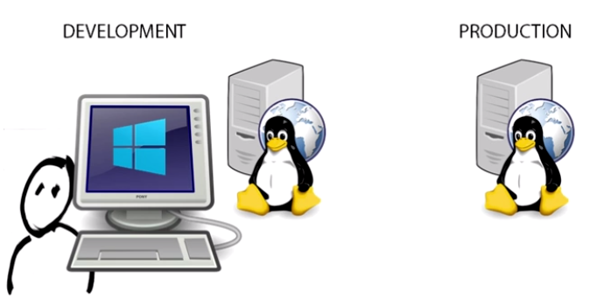
5. What if at the start of each day you could launch a development environment for a single project and then when you're done with that project shut down the development environment and go home, or move on to another project? That way the resources you need for a particular project are freed up once you're done and don't linger. 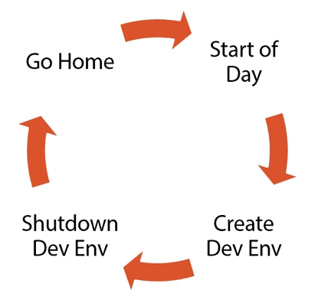
6. Are you responsible for configuring test and production environments? Like what software is installed, or what OS features are enabled? Tired of hoping you know what is necessary to reproduce the changes in production?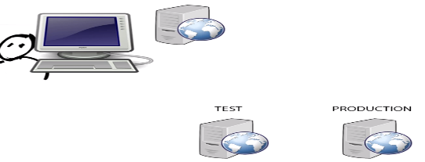
7. What if you could quickly create local environments to experiment with the actual scripts used to provision test and production environments, and when you get stuck, or you want to quickly test things, what if resetting were as easy as destroying the environment and recreating it?
8. What if the scripts you created were checked into version control and could be reused across environments from development through to production? What if everyone could collaborate on version scripts to configure environments? What if these were tested as part of a continuous integration process?

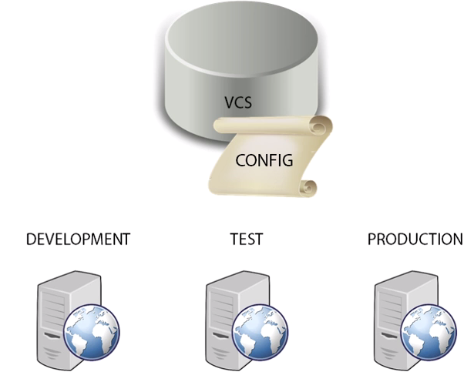

Works on my machine could be a thing of the past. Much of this is possible by leveraging automation to quickly create isolated virtual environments. **Of course, we've had virtualization for years, but setting up this work flow has historically been so time consuming it's rarely been worth the trouble, but now with Vagrant that's changing. Vagrant abstracts the painful parts.**

Vagrant makes it easy to create virtual machines and automatically install all the software necessary for a particular project.

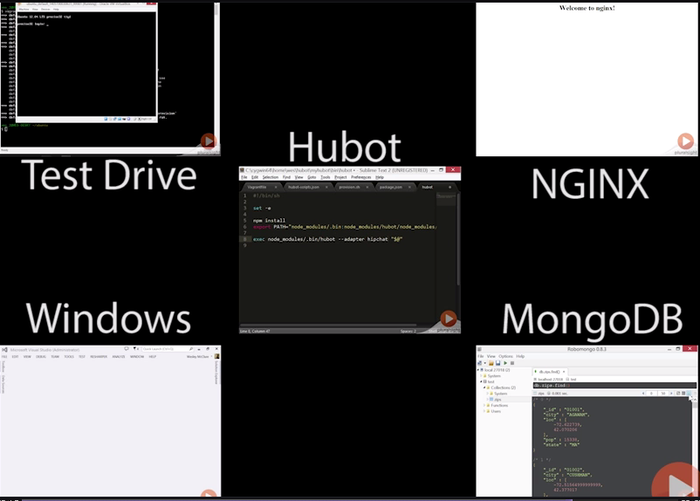

One of the benefits of Vagrant is that it abstracts virtualization, so we're going to need a hypervisor to run virtual machines.

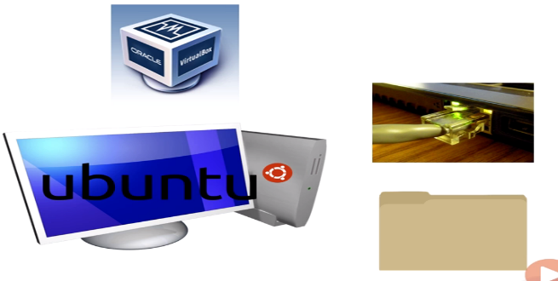

**LAB**

We will build an environment that allows us to host websites with NGINX. Alternatives: Apache, IIS, Tomcat.

What if you could develop in an environment that was a clone of production, or pretty close to it?

Even if you're development machine(Windows/MAC) is completely different and what if the configuration of NGINX(UBUNTU),

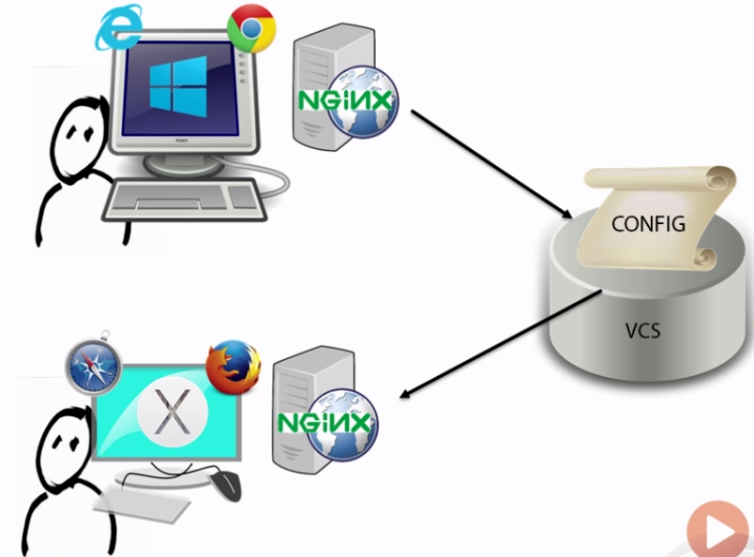

--webserver were entirely scripted, instead of in an outdated read me file, or

--What if this script were checked into version control and anyone else could clone the repository and spin up the exact same environment, even if they preferred using say OSX instead of Windows.

--Any developer could make changes with the tools they love and test the site with NGINX running inside an Ubuntu VM.

The same environment every other developer tests with, **they'd even be able to run the site in whatever browser they like on their own development machine**.

We're going to look at how we can use Vagrant to maintain a reusable, predictable development environment.

🡪The Vagrant file is the heart of configuring the environments that Vagrant will manage for you.

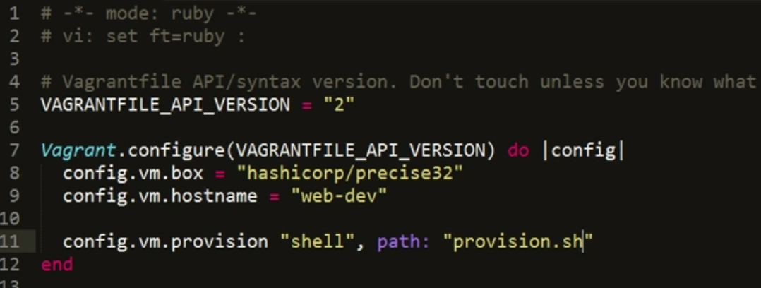

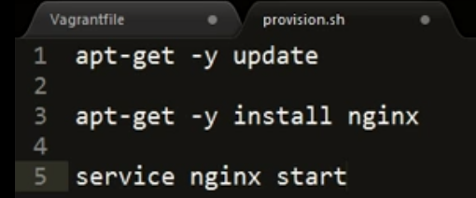

We could SSH in and install NGINX, but we wouldn't have any way to automatically reproduce this for other developers.

It’d be even better if we could share scripts to configure the software on the VM, this is referred to as previsioning. Provisioning provides whatever else we need beyond the base box we used to launch the VM. The most basic type of provisioning is a simple shell script.

Why Provisioning?

- Env. Doesn’t change often

- Time Consuming

- Idempotent

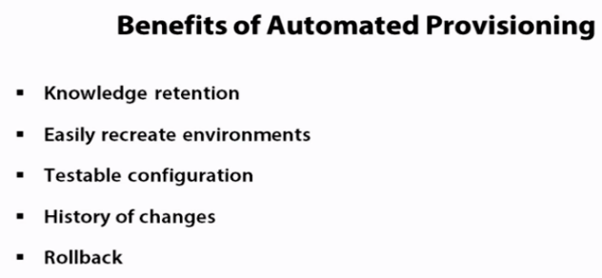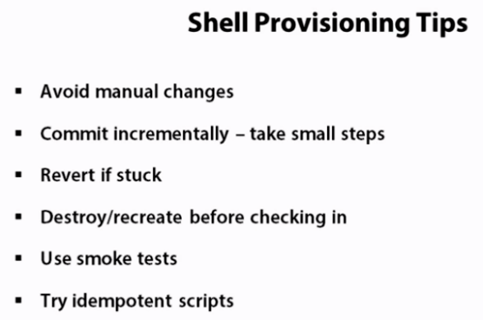

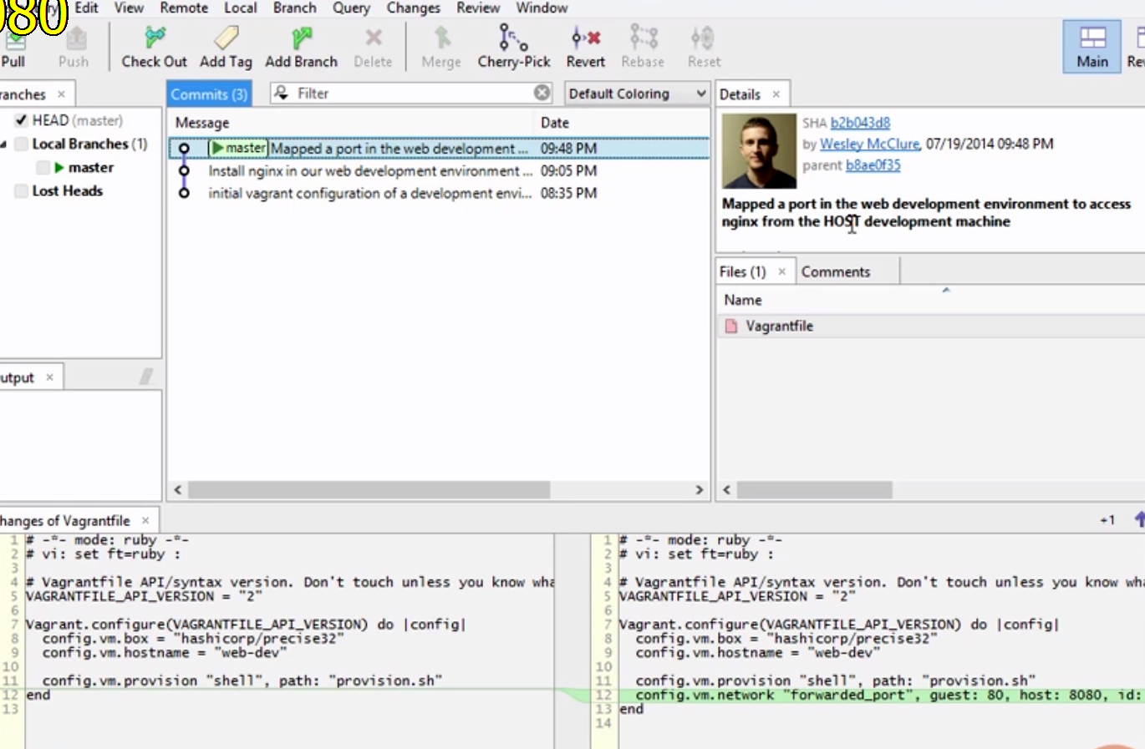

Now that we have several commits we can step through the changes we've made to our web development environment. Think of how powerful this is.

1.) We can literally see a diff of the development environment and as we leverage Vagrant for other environments we'll be able to see the diffs of each of these environments as well.

For example, here is that port forwarding change we made. We can clearly see the configuration change we added to add the forwarded port.

2.) We can see when we did it, who did it and we can get an explanation of why they made that change to the environment.

3.) At any time we can roll back to an old version of our infrastructure, that's pretty powerful.

**Auto-correct**

For example I've set up here a situation with a set of colliding ports and I'm going to run Vagrant up on a halted machine and as you can see it warns us that the forwarded ports have collided and that it won't start the VM.

If you'd like Vagrant to attempt to automatically correct for this use the autocorrect option, this is off by default as it would likely not be expected.

if we run Vagrant up again you'll see Vagrant has detected the colliding ports and corrected 8080 to now be on port 2200.



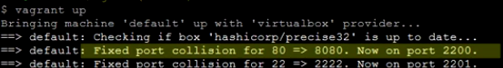

There is one exception to autocorrect being off by default and that is for SSH, of course since we normally would just use Vagrant SSH to SSH into the machine we don't really care what port it's running on, so Vagrant will automatically handle collisions in the SSH port.

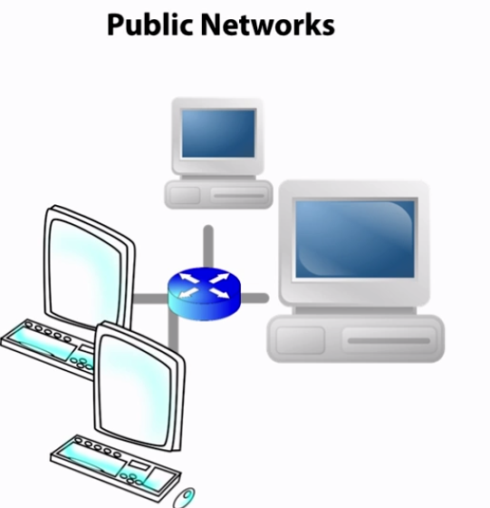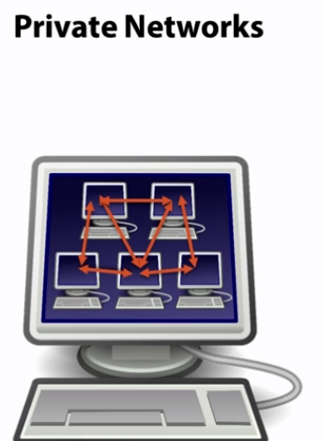

**Modify the site files.**

Right now we'd have to modify the files on the guest VM. There is simply no easy way to modify them via the host. Let's change this so we can access the files from both the host and the guest.

Once we have the files accessible in both locations we can make sure we check the site code into version control too. After all, we wouldn't want to recreate our site code every time we spin up a new VM.

Just to keep things simple let's reuse the default index page that NGINX installed.

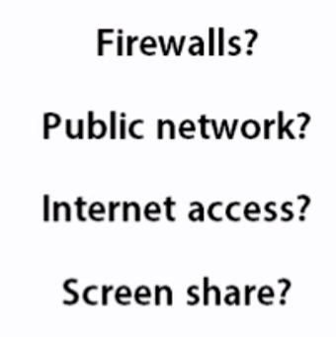

**First steps with provisioning of Docker containers using Vagrant as provider**

Vagrant has been a great tool for me to produce VirtualBox machine images that I use for a host of things including development environments. I have frequently used Puppet in conjunction with Vagrant to do the detailed configuration of the Virtual Machine – including the installation of various software packages.

**Docker is of interest for several reasons:**

Docker containers while isolated share their host operating systems and its physical resources which means that a collection of Docker containers can provide (almost) the same isolation as a series of Virtual Machines but with much smaller overhead – in terms of usages of disk, CPU and memory and in terms of time required for starting up and shutting down.

Additionally, the management of Docker containers – from 10Ks of images to start from and a layered mechanism to extend and revert – has a number of attractive options.

A Docker container – once configured and runnable – can be distributed fairly easily – using a public or private registry – and can also be deployed to a growing number of enterprise stacks (such as OpenStack cluster) and public cloud providers.

Docker requires a Linux host as Docker itself leverages the LXC (Linux Containers) mechanism in Linux. This means that in order to work with Docker on non-Linux systems – Windows, Mac OS X, Solaris – we first need to set up a Virtual Machine running Linux. The special boot2docker package is a lightweight Linux distribution made specifically to run [Docker](https://www.docker.com/) containers. A quick way on Windows and OS X to get started with Docker is by using boot2docker as an intermediate mechanism.

The association between Vagrant and Docker is threefold:

1. automate the building of Docker containers
2. coordinate running of Docker containers
3. provide a Docker enabled host VM on which Docker is run

1. Vagrant can be used to run Docker containers – with vagrant up resulting in the configured container(s) being run. Vagrant supports special commands to produce logging from Docker containers and to run one-off commands in a container. The Vagrant way of defining folder mapping is leveraged through Docker volume instructions, resulting in host folders being accessible inside the Docker container.

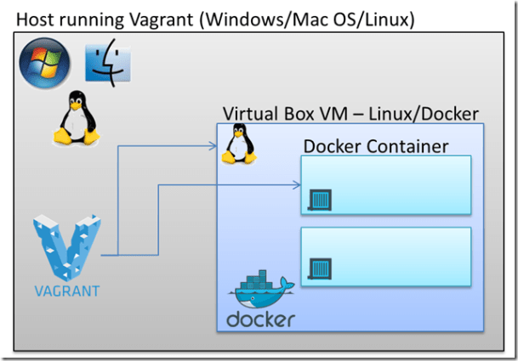

2. Vagrant has embraced Docker as a provider, just as it supports providers for VirtualBox and VMWare. This means that a Vagrant configuration file can describe a Docker container just as it can describe the configuration of a VirtualBox VM.

3. One very nice additional touch is that Vagrant is aware of the fact that Docker containers cannot run natively at present on Windows or Mac OS X.

**When Vagrant is asked to provision a Docker container on one of these operating systems, it can either automatically engage boot2docker as a vehicle to create and run the Docker container in or provision a Linux based VM image that it then enables for Docker and creates the Docker container into. Using a traditional Vagrant file, we can describe the Docker host VM that we want Vagrant to create or leverage (if it already exists).** This host VM can of course be made to look much more like a production Linux host than the boot2docker environment. The same Docker host VM that Vagrant creates can be reused for many Docker containers provided by Vagrant: a single Linux VM suffices for running multiple containers that can mutually be linked and share file system folders. Vagrant can also provision such a Docker VM when it is running on Linux on which it could also natively install Docker can build containers.

-🡪This article is an overview of my first steps with the combination of Vagrant and Docker (on Windows) – and really not much more than a rehash of the best parts provided in several great articles listed in the Resources section. It is a stepping stone towards automated environment provisioning using Vagrant, Docker and Puppet and provides some examples that address the main challenges I faced in getting started.

**Simple first step – build and run a Docker container**

Using three files on my Windows laptop that has both VirtualBox and Vagrant installed

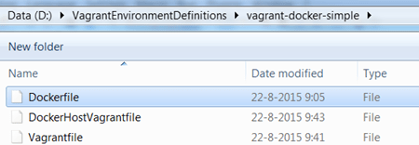

I will create and run a very simple Docker container, based on the Ubuntu 14.04 image. The container will do very little of interest: it pings localhost 51 times and exits again. This gives us some time to inspect the container, ping it, attach to it and look at its output. Later on in this article, things will get a little more interesting.

